SD
...
The
Multi-value String
Database

Chapter 1.1 – Installation - Debian 12 with Gnome or Ubuntu 24.04
This chapter will document how to install SD on Ubuntu 24.04. Open a terminal window and type “sudo apt update && sudo apt full-upgrade” to make sure that the OS software is current.
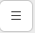
When the upgrade is finished, reboot and log in again. Open a terminal window and click the hamburger menu icon (shown at left) on the right side of the title bar. Select “Preferences” from the drop down menu. In the Preferences windows, click “Unnamed” on the left side panel.
As shown in the figure below, the “Initial terminal size:’” should be 120 columns by 36 rows. You may also want to select the “Custom font:” check box and change the font size.
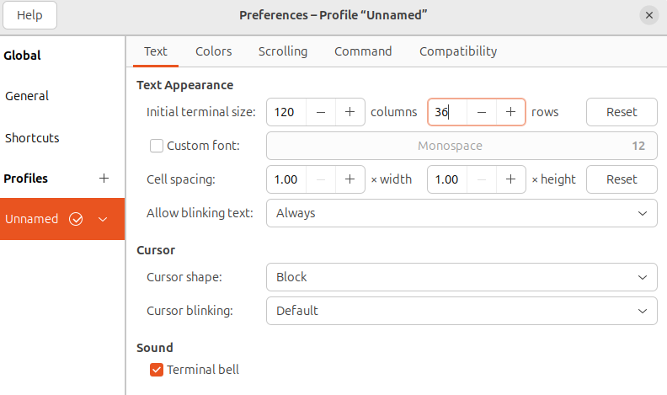
When you have made your changes, close the window by clicking the “X” in the upper right corner of the window. Now reopen the terminal and you should see that the terminal window now has the dimensions that you asked for.
In the open terminal type the following commands:
sudo apt install git
git clone https://github.com/stringdatabase/sdb64
The source code repository will be copied from the github server and will create the sdb64 directory underneath your home directory.
Now type the following commands:
cd sdb64
./debian-installsd.sh
Press “y” and then “Enter” when asked “Continue?”
Enter your password when requested.
At the “<cr> to INSTALL “Q” to exit prompt just press “Enter”
At the “Restart computer now?” enter “y”.
When the computer has restarted, open a terminal. Enter “sd” . At the colon prompt:
Type “LISTF” to see a list of the files assigned to your user account.
Type “WHO” to see your user name.
Type “!pwd” to see where your personal account directory is located.
Type “OFF” to exit the database and return to the operating system prompt.
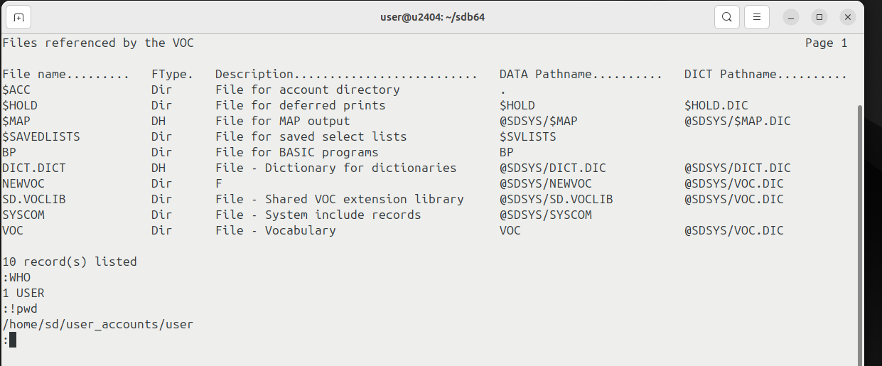
To log into the database as the administrator type “sudo sd” and enter your password when requested at the operating system prompt. You must have ‘sudo’ priviledges on your computer to access the administrator account.
Type “LISTF” to see a list of files assigned to the administrator account.
Type “WHO” and you will see that the name of the administrator account is “SDSYS’.
Type “!pwd” to see where where the SDSYS account directory is located.
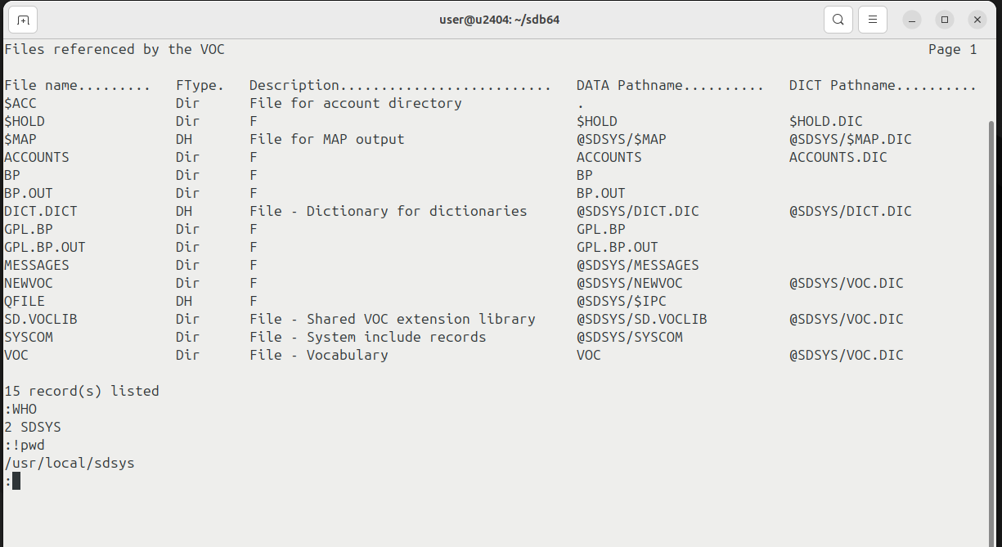
As with the personal account, enter “OFF” to exit to the operating system prompt.

Chapter 1.2 – Installation – Fedora 40
This chapter will document how to install SD on Fedora 40. Open a terminal window and type “sudo dnf update” to make sure that the OS software is current.and e
When the upgrade is finished, reboot and log in again. Open a terminal window and click the hamburger menu icon (shown at left) on the right side of the title bar. Select “Preferences” from the drop down menu. In the Preferences windows, click “Unnamed” on the left side panel.
As shown in the figure below, the “Initial terminal size:’” should be 120 columns by 36 rows. and e You may also want to select the “Custom font:” check box and change the font size.

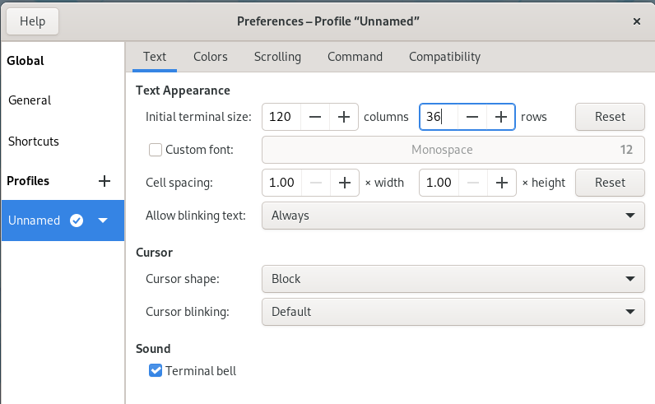
When you have made your changes, close the window by clicking the “X” in the upper right corner of the window. Now reopen the terminal and you should see that the terminal window now has the dimensions that you asked for.
The source code repository will be copied from the github server and will create the sdb64 directory underneath your home directory.
In the open terminal type the following commands:
sudo dnf install git
git clone https://github.com/stringdatabase/sdb64
The source code repository will be copied from the github server and will create the sdb64 directory underneath your home directory.Now type the following commands:
cd sdb64|
./fedora-installsd.sh
enter “y” at the “Continue?” prompt.
Enter your password when requested.
At the “<cr> to INSTALL “Q” to exit prompt just press “Enter”
At the “Restart computer now?”Enter “y”
When the computer has restarted, open a terminal Enter “sd”. At the colon prompt:
Enter “LISTF” to see a list of the files assigned to your user account.
Enter “WHO” to see your user name.
Enter “!pwd” to see where your personal account directory is located.
Enter “OFF” to exit the database and return to the operating system prompt.
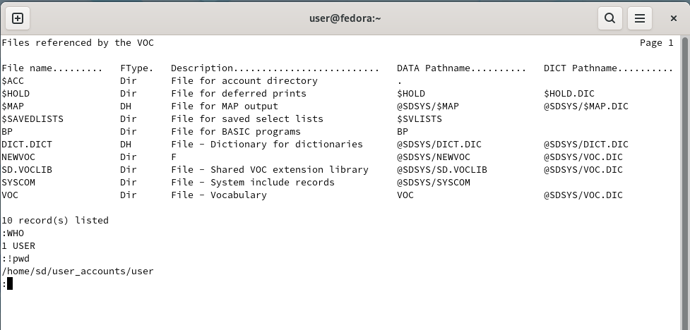

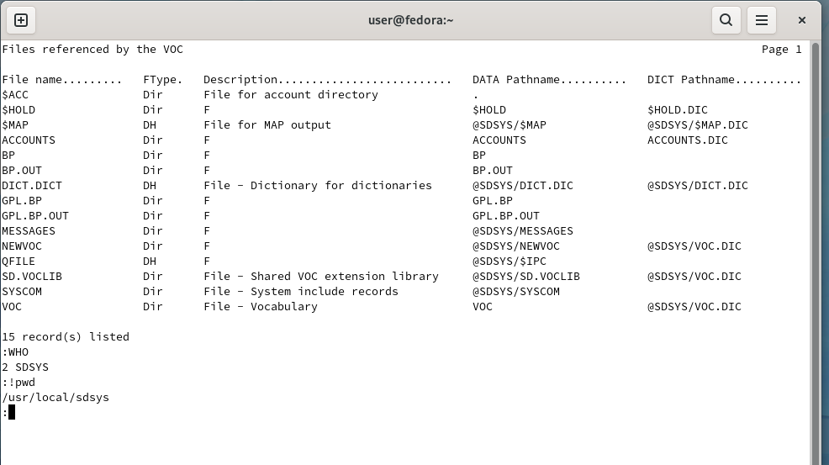
To log into the database as the administrator type “sudo sd” and enter your password when requested at the operating system prompt. You must have ‘sudo’ priviledges on your computer to access the administrator account.
Type “LISTF” to see a list of files assigned to the administrator account.
Type “WHO” and you will see that the name of the administrator account is “SDSYS’.
Type “!pwd” to see where where the SDSYS account directory is located.
As with the personal account, enter “OFF” to exit to the operating system prompt.

Chapter 1.3 – Installation on server without a GUI

SD can also be installed on the servers that do not have a graphical user interface (GUI). Debian 12, Ubuntu 24.04 and Fedora 40 servers are supported.
The process is very similar to those discussed for the desktop versions that were covered in the preceding Chapters. Once you have logged in you can issue the following commands to install SD.
Ubuntu 24.04 Server or Debian 12 | Fedora 40 Server
sudo apt update && sudo apt full-upgrade | sudo dnf update
sudo apt install git | sudo dnf install git
git https://github.com/stringdatabase/sdb64 | git https://github.com/stringdatabase/sdb64
cd sdb64 | cd sdb64
./debian-installsd.sh | ./fedora-installsd.sh
sudo reboot | sudo reboot
login | login
“sd” = user account “sudo sd” = admin account | “sd” = user account “sudo sd” = admin account

Chapter 2 – TCL – The Command Line

